**LINUX TRAINING**

**Date:14/11/2024**

**Linux:**

Linux is operating system and is a kernel

Linux Structure:

1.Hardware:Hardware is the main part of linux, where all the physical structure is present

2.kernel: kernel is the heart of the linux where different devices can access and multitasking and file system.

3.shell: sh, tesh, bash are part of shell

4.utilities: sort , cat, wc, emacs, grep, awk are part of utilities

**History:**

Richard stallman and others written set of programs and they are called utilities

Linus toward developed linux in 1991 and now 10,000 + developers are working in it from ibm and other companies

**World wide web:**

67% of www servers are run in linux (2016)

Research, performance and compute: google, amazon, nsa, 100% of top 500 computers

Moder devices and smartphones like amazon kindle,smart tv or devices

Why Linux :

The most common as used by boston research is linux

Local system is connected to remot server

Protocols and software:

Ssh, sftp

**Shell main commands:**

Whoami : #mylogin

hostname : #name of computer



echo “Hellow world” : #print characters to screen



echo $home : #print environment variables



echo my login x $(whoami): #replace $(xx) with output

date : #print current date

cal : #print calender

not working

shazam : #bad command

**Commands: selected text processing utilities**

Awk : pattern scanning and processing language

cat : display files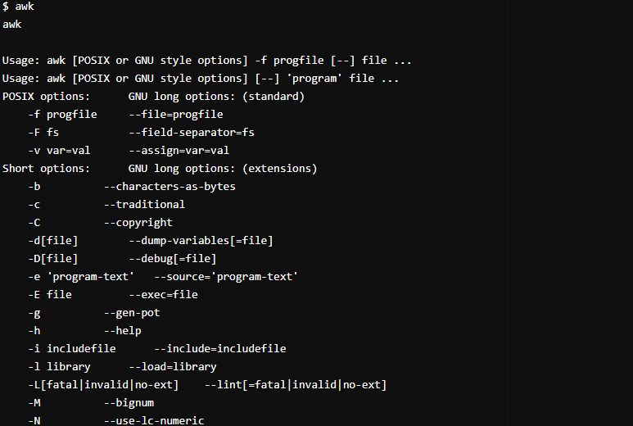

cut : extract selected fields of each line of a file

diff: compare two files

grep: search text for a pattern

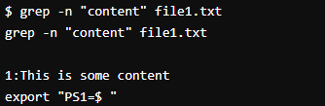

head: display the first part of file

less: display files on a page by page basis

sed: stream editor

sort: sort text files

Split: split files

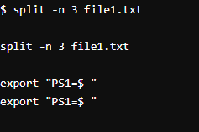

Tail: Display the last part of a file

Tr: Translate or delete characters

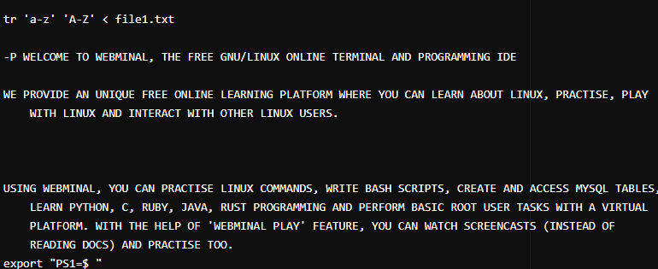

Uniq: Filter out repeated liens in a file

Wc: Line,word and character count

Mv: to rename a file

Cp: copy a file

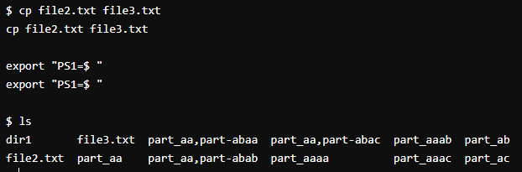

Mv: change file from one directory to another

**Creating file with bunch of paragraphs:**

Less: displays content of a file in pages

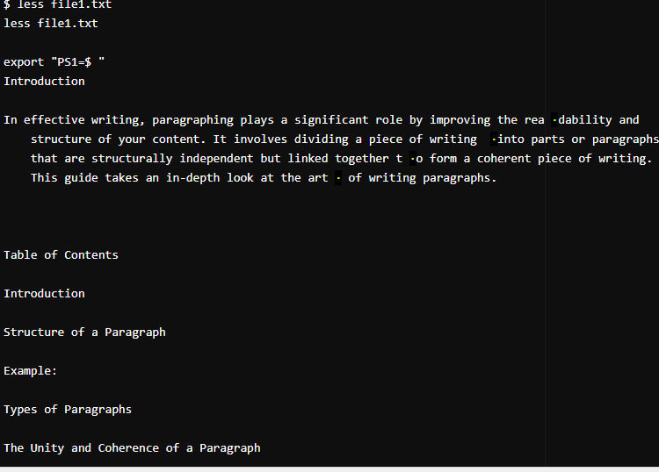

Split: splits the file into multiple files

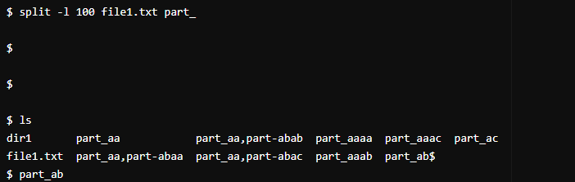

Wc: word count of a file

